View of Ministry

The vocation of an ordained minister is for those who are called by God to a ministry of Word, Sacrament and Order. But more than that, I am called to enable and empower the people of God. The Book of Discipline outlines the various duties of an ordained minister, but there is so much more involved. It is being there for the people of my parish when they need spiritual help. It is the ministry of presence when words are not enough. It is living out, to the best of my ability, the life of Christ’s representative here on earth.
As a servant of Christ, I am continually growing and searching. As a minister, I believe that my strengths are in my enjoyment of learning and growing in the faith. By interacting with all types of people and enabling them and empowering them to make the most of the gifts they have been given by God. Home and hospital visitation is very important to my ministry. It is in the home that you can truly get to know the people who are worshipping on Sunday morning. If I do not know my people personally, then I do not believe that I can be of as much help as I could be in a crisis situation. My people need to know and trust me as well, not only as a minister who is there for them, will keep confidences, but also as a person. Also, when you know your people, and they know you, worship becomes more personal and meaningful.
I believe I am able to relate to all age groups. I do enjoy working with the children and youth, watching them grow in the faith is so very special. I also enjoy hearing the stories of the older members. They have experiences to share and we need to learn from them. Being with the people of my own generation is always a joy. To remember, share similar experiences, to challenge each other in our faith journey.
I believe that worship should be a positive experience that is sacred, meaningful, and yes fun. The type of worship experience is not the important factor; worship of God is the main emphasis of the service. Worship is not the minister talking and the people listening, but an exchange between them and hopefully spiritual growth for all of them.

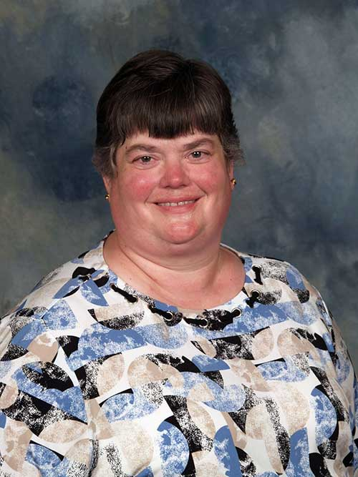

Carolyn Berry
Conference Membership
Full Elder

Churches and Appointments Served:
- Smithville UMC (2015 - Present
- Portage Faith UMC (2005 – 2015)
- Church of the Saviour UMC (Cleveland) (1998 - 2005)
- Union/Salem UMCs (1995 - 1998)
- Philadelphia/Evans Mills UMCs (N. Central NY Conference)
(1990 – 1995)
- Burbank Charge UMC, Student appointment (1988 - 1990)

Education:
- M.T.S.O. – M.Div. (1990)
- University of Cincinnati – BSW (1983)
- Highland High School, Medina (1979)

Additional Education and Training:
- Vanderbilt University, MSN
- Pittsburgh Theological, D. Min.

Special Activities, Secular Memberships & Offices

- Workshop leader for Youth (2003 – 2007)
- Design team for Youth Ministry Institute at MTSO
(2000 – 2003)
- Guest lecturer for Hiram College School of Nursing
(2010 - 2014)

Board and Committee Membership & Offices

- Canal District Superintendency Committee (current chair)
- Conference Board of Ministry
- Conference Worship Committee
- Conference Board of Camps and Retreats
- Disciple trained

Ministry Gifts

- Pastoral Care
- Relational
- Immerses herself in the community

